### **Understanding DNS**

**1. Introduction to Domain Name System (DNS)**

* **Origins of DNS**: DNS is likened to a phone book for the Internet, translating human-friendly domain names into IP addresses that computers use to identify each other.
* **What is DNS?**: DNS is the Internet’s naming service, mapping domain names to IP addresses. This process is transparent to users. When a user enters a domain name in a browser, DNS translates it to an IP address to forward the request to the destination web server.
* **Important Details**:
  + **Name Servers**: DNS infrastructure consists of numerous servers, with DNS servers that respond to queries called name servers.
  + **Resource Records (RR)**: These are the smallest units of DNS information, containing domain name to IP address mappings. Types include A (hostname to IP address), NS (authoritative DNS for a domain), CNAME (alias to canonical hostname), and MX (mail server alias to canonical hostname).
  + **Caching**: DNS uses caching at different layers to reduce latency and burden on DNS infrastructure.
  + **Hierarchy**: DNS servers are organized hierarchically, making the system scalable.

**2. How the Domain Name System Works**

* **DNS Hierarchy**:
  + **DNS Resolver**: Initiates queries, often within the user’s network, and can use caching.
  + **Root-level Name Servers**: Handle top-level domain names and forward requests to TLD servers.
  + **Top-level Domain (TLD) Name Servers**: Manage IP addresses of authoritative servers.
  + **Authoritative Name Servers**: Provide the IP addresses of web/application servers.
* **Query Resolution**:
  + **Iterative Query**: Local server requests IP addresses from root, TLD, and authoritative servers.
  + **Recursive Query**: End user’s request passes through the local server, which then queries the root DNS servers.

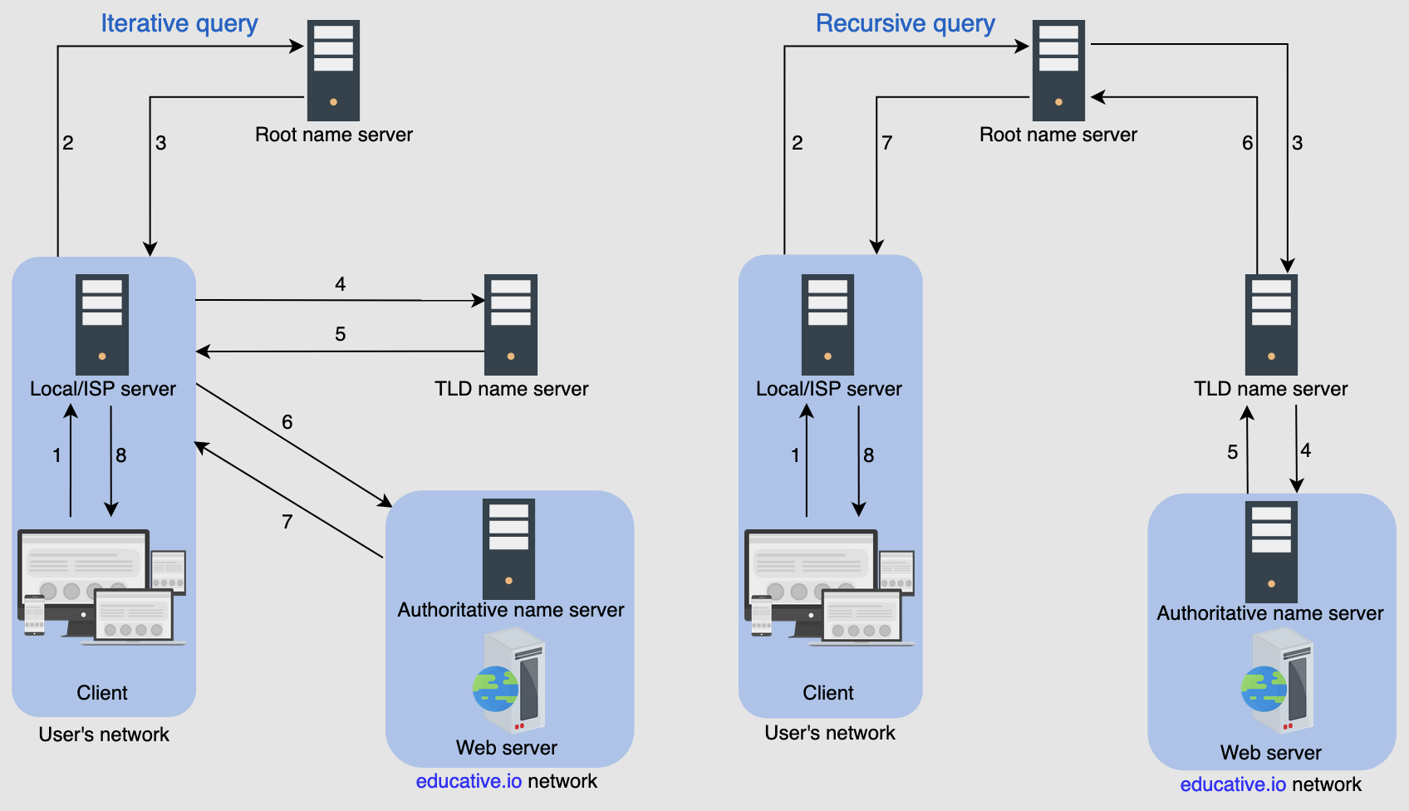

* **Caching**: Temporary storage of frequently requested resource records to reduce response time and network traffic. Caching occurs at the browser, OS, local name server, or ISP’s DNS resolver.
* **DNS as a Distributed System**:
  + **Advantages**: Avoids single points of failure, low query latency, and flexible maintenance.
  + **Scalability**: Hierarchical structure allows handling large query loads efficiently.
  + **Reliability**: Achieved through caching, server replication, and using UDP for quick responses.
  + **Consistency**: Ensures eventual consistency with updates propagated across DNS servers, though caching can sometimes lead to outdated information.
* **Testing DNS**:
  + **Commands**: nslookup and dig can be used to test and understand DNS query responses.
  + **Non-authoritative Answer**: Indicates a cached response from intermediary servers, not the authoritative server.
  + **Load Balancing**: DNS can distribute traffic to different IP addresses to balance the load.

### **Summary**

DNS is essential for translating human-friendly domain names into machine-readable IP addresses, facilitating communication on the Internet. It operates as a distributed, hierarchical, and highly scalable system, employing caching to enhance performance and reliability. Understanding its components, query mechanisms, and how caching works can provide deeper insights into its functionality and efficiency.